Databricks Certified Data Engineer Associate Test 2

Question 1

You are designing an analytical to store structured data from your e-commerce platform and unstructured data from website traffic and app store, how would you approach where you store this data?

- Use traditional data warehouse for structured data and use data lakehouse for unstructured data.
- Data lakehouse can only store unstructured data but cannot enforce a schema
- Data lakehouse can store structured and unstructured data and can enforce schema (Correct answer)
- Traditional data warehouses are good for storing structured data and enforcing schema

Overall explanation
What Is a Lakehouse? - The Databricks Blog
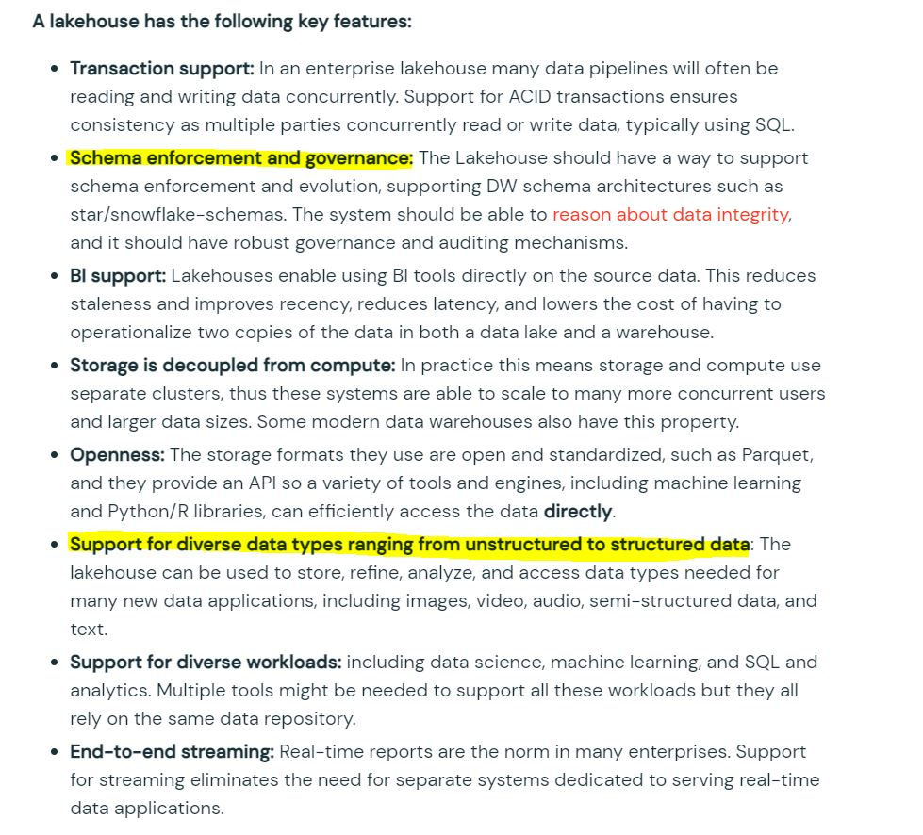

Domain - Databricks Lakehouse Platform

Question 2

What is the best way to describe a data lakehouse compared to a data warehouse?

- A data lakehouse provides a relational system of data management
- A data lakehouse captures snapshots of data for version control purposes.
- A data lakehouse couples storage and compute for complete control.
- A data lakehouse utilizes proprietary storage formats for data.
- A data lakehouse enables both batch and streaming analytics. (Correct answer)

Overall explanation
A lakehouse has the following key features:
- Transaction support: In an enterprise lakehouse many data pipelines will often be reading and writing data concurrently. Support for ACID transactions ensures consistency as multiple parties concurrently read or write data, typically using SQL.
- Schema enforcement and governance: The Lakehouse should have a way to support schema enforcement and evolution, supporting DW schema architectures such as star/snowflake-schemas. The system should be able to reason about data integrity, and it should have robust governance and auditing mechanisms.
- BI support: Lakehouses enable using BI tools directly on the source data. This reduces staleness and improves recency, reduces latency, and lowers the cost of having to operationalize two copies of the data in both a data lake and a warehouse.
- Storage is decoupled from compute: In practice this means storage and compute use separate clusters, thus these systems are able to scale to many more concurrent users and larger data sizes. Some modern data warehouses also have this property.
- Openness: The storage formats they use are open and standardized, such as Parquet, and they provide an API so a variety of tools and engines, including machine learning and Python/R libraries, can efficiently access the data directly.
- Support for diverse data types ranging from unstructured to structured data: The lakehouse can be used to store, refine, analyze, and access data types needed for many new data applications, including images, video, audio, semi-structured data, and text.
- Support for diverse workloads: including data science, machine learning, and SQL and analytics. Multiple tools might be needed to support all these workloads but they all rely on the same data repository.
- End-to-end streaming: Real-time reports are the norm in many enterprises. Support for streaming eliminates the need for separate systems dedicated to serving real-time data applications.

Domain - Databricks Lakehouse Platform

Question 3
Which of the following is a correct statement on how the data is organized in the storage when when managing a DELTA table?

- All of the data is broken down into one or many parquet files, log files are broken down into one or many JSON files, and each transaction creates a new data file(s) and log file. (Correct answer)
- All of the data and log are stored in a single parquet file
- All of the data is broken down into one or many parquet files, but the log file is stored as a single json file, and every transaction creates a new data file(s) and log file gets appended.
- All of the data is broken down into one or many parquet files, log file is removed once the transaction is committed.
- All of the data is stored into one parquet file, log files are broken down into one or many json files.

Overall explanation
Here is sample layout of how DELTA table might look,
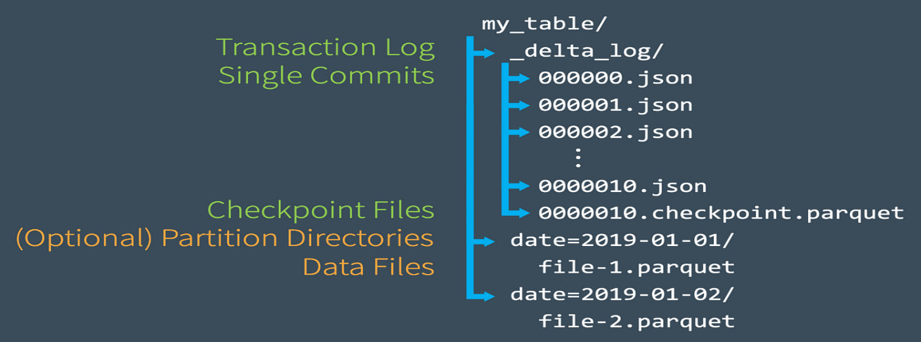

Domain - Databricks Lakehouse Platform

Question 4

As a Data Engineer, you were asked to create a delta table to store below transaction data?

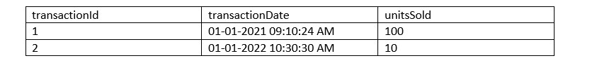
- CREATE DELTA TABLE transactions (
- transactionId int,
- transactionDate timestamp,
- unitsSold int)
- CREATE TABLE transactions (
- transactionId int,
- transactionDate timestamp,
- unitsSold int)
- FORMAT DELTA
Your answer is correct
- CREATE TABLE transactions (
- transactionId int,
- transactionDate timestamp,
- unitsSold int)
- CREATE TABLE USING DELTA transactions (
- transactionId int,
- transactionDate timestamp,
- unitsSold int)
- CREATE TABLE transactions (
- transactionId int,
- transactionDate timestamp,
- unitsSold int)
- LOCATION DELTA
Overall explanation
When creating a table in Databricks by default the table is stored in DELTA format.
Domain - Databricks Lakehouse Platform

Question 5

How does a Delta Lake differ from a traditional data lake?

- Delta lake is Datawarehouse service on top of data lake that can provide reliability, security, and performance
- Delta lake is a caching layer on top of data lake that can provide reliability, security, and performance
- Delta lake is an open storage format like parquet with additional capabilities that can provide reliability, security, and performance (Correct answer)
- Delta lake is an open storage format designed to replace flat files with additional capabilities that can provide reliability, security, and performance
- Delta lake is proprietary software designed by Databricks that can provide reliability, security, and performance

Overall explanation

Delta lake is
· Open source
· Builds up on standard data format
· Optimized for cloud object storage
· Built for scalable metadata handling
Delta lake is not
· Proprietary technology
· Storage format
· Storage medium
· Database service or data warehouse

Domain - Databricks Lakehouse Platform

Question 6

Newly joined data analyst requested read-only access to tables, assuming you are owner/admin which section of Databricks platform is going to facilitate granting select access to the user

- Admin console
- User settings
- Data explorer (Correct answer)
- Azure Databricks control pane IAM
- Azure RBAC

Overall explanation
https://docs.databricks.com/sql/user/data/index.html
Data explorer lets you easily explore and manage permissions on databases and tables. Users can view schema details, preview sample data, and see table details and properties. Administrators can view and change owners, and admins and data object owners can grant and revoke permissions.
Domain - Databricks Lakehouse Platform

Question 7

You noticed that colleague is manually copying the notebook with _bkp to store the previous versions, which of the following feature would you recommend instead.

- Databricks notebooks support change tracking and versioning (Correct answer)
- Databricks notebooks should be copied to a local machine and setup source control locally to version the notebooks
- Databricks notebooks can be exported into dbc archive files and stored in data lake
- Databricks notebook can be exported as HTML and imported at a later time

Overall explanation
When you are editing the notebook on the right side check version history to view all the changes, every change you are making is captured and saved.
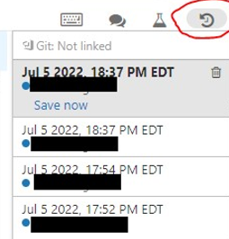

Domain - Databricks Lakehouse Platform

Question 8

Which of the following describes how Databricks Repos can help facilitate CI/CD workflows on the Databricks Lakehouse Platform?

- Databricks Repos can facilitate the pull request, review, and approval process before merging branches
- Databricks Repos can merge changes from a secondary Git branch into a main Git branch
- Databricks Repos can be used to design, develop, and trigger Git automation pipelines
- Databricks Repos can store the single-source-of-truth Git repository
- Databricks Repos can commit or push code changes to trigger a CI/CD process (Correct answer)

Overall explanation
See below diagram to understand the role Databricks Repos and Git provider plays when building a CI/CD workdlow.
All the steps highlighted in yellow can be done Databricks Repo, all the steps highlighted in Gray are done in a git provider like Github or Azure Devops.
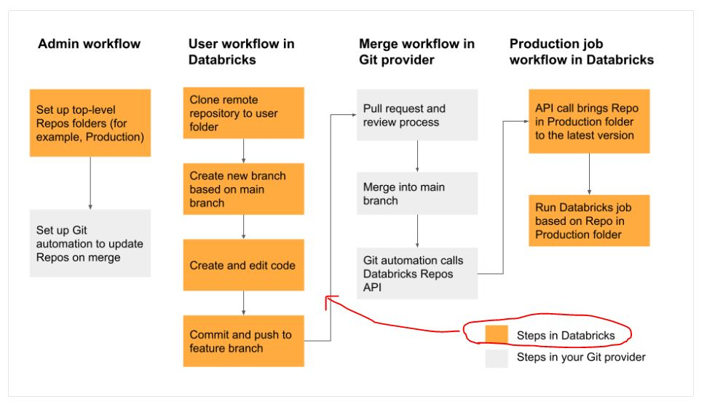
Domain - Databricks Lakehouse Platform

Question 9Correct

You are currently working on a production job failure with a job set up in job clusters due to a data issue, what cluster do you need to start to investigate and analyze the data?

- A Job cluster can be used to analyze the problem
- All-purpose cluster/ interactive cluster is the recommended way to run commands and view the data. (Correct answer)
- Existing job cluster can be used to investigate the issue
- Databricks SQL Endpoint can be used to investigate the issue

Overall explanation
A job cluster can not provide a way for a user to interact with a notebook once the job is submitted, but an Interactive cluster allows to you display data, view visualizations write or edit quries, which makes it a perfect fit to investigate and analyze the data.
Domain - Databricks Lakehouse Platform

Question 10

What is the purpose of the bronze layer in a Multi-hop architecture?

- Can be used to eliminate duplicate records
- Used as a data source for Machine learning applications.
- Perform data quality checks, corrupt data quarantined
- Contains aggregated data that is to be consumed into Silver
- Provides efficient storage and querying of full unprocessed history of data (Correct answer)

Overall explanation
Medallion Architecture – Databricks
Bronze Layer:
- Raw copy of ingested data
- Replaces traditional data lake
- Provides efficient storage and querying of full, unprocessed history of data
- No schema is applied at this layer

Domain - Incremental Data Processing

Question 11
A dataset has been defined using Delta Live Tables and includes an expectations clause: CONSTRAINT valid_timestamp EXPECT (timestamp > '2020-01-01') ON VIOLATION FAILWhat is the expected behavior when a batch of data containing data that violates these constraints is processed?

- Records that violate the expectation are added to the target dataset and recorded as invalid in the event log.
- Records that violate the expectation are dropped from the target dataset and recorded as invalid in the event log.
- Records that violate the expectation cause the job to fail (Correct answer)
- Records that violate the expectation are added to the target dataset and flagged as invalid in a field added to the target dataset.
- Records that violate the expectation are dropped from the target dataset and loaded into a quarantine table.

Overall explanation
Delta live tables support three types of expectations to fix bad data in DLT pipelines
Review below example code to examine these expectations
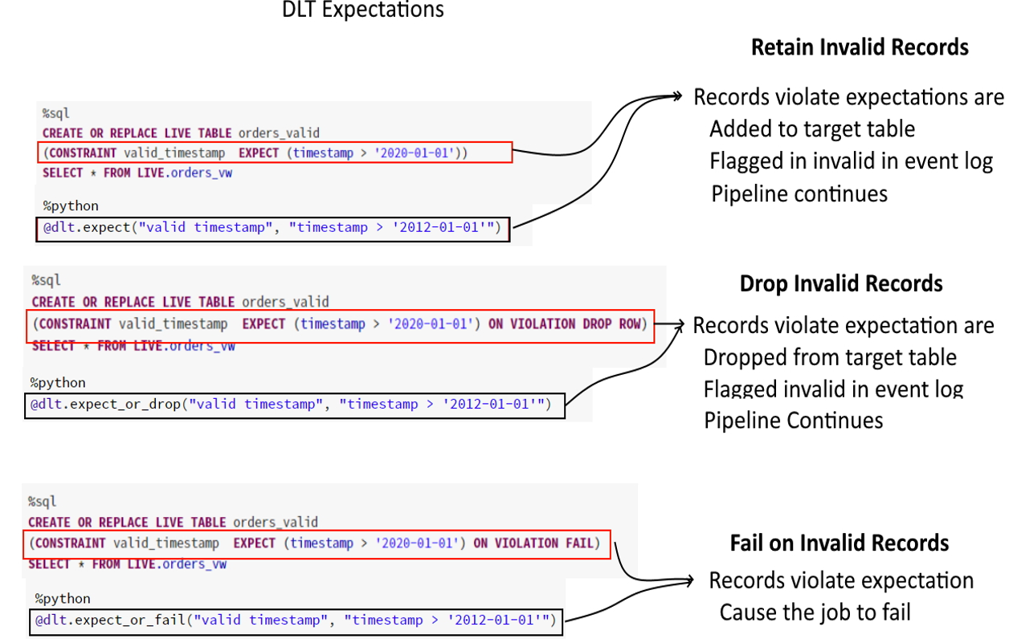
Invalid records:
Use the expect operator when you want to keep records that violate the expectation. Records that violate the expectation are added to the target dataset along with valid records:
SQL
CONSTRAINT valid_timestamp EXPECT (timestamp > '2020-01-01')
Drop invalid records:
Use the expect or drop operator to prevent the processing of invalid records. Records that violate the expectation are dropped from the target dataset:
SQL
CONSTRAINT valid_timestamp EXPECT (timestamp > '2020-01-01') ON VIOLATION DROP ROW
Fail on invalid records:
When invalid records are unacceptable, use the expect or fail operator to halt execution immediately when a record fails validation. If the operation is a table update, the system atomically rolls back the transaction:
SQL
CONSTRAINT valid_timestamp EXPECT (timestamp > '2020-01-01') ON VIOLATION FAIL UPDATE

Domain - Incremental Data Processing
Question 12

What is the purpose of a silver layer in Multi hop architecture?

- Replaces a traditional data lake
- Efficient storage and querying of full and unprocessed history of data
- A schema is enforced, with data quality checks. (Correct answer)
- Refined views with aggregated data
- Optimized query performance for business-critical data

Overall explanation
Medallion Architecture – Databricks
Silver Layer:
- Reduces data storage complexity, latency, and redundency
- Optimizes ETL throughput and analytic query performance
- Preserves grain of original data (without aggregation)
- Eliminates duplicate records
- production schema enforced
- Data quality checks, quarantine corrupt data

Domain - Incremental Data Processing

Question 13Correct

What is the purpose of a gold layer in Multi-hop architecture?

- Optimizes ETL throughput and analytic query performance
- Eliminate duplicate records
- Preserves grain of original data, without any aggregations
- Data quality checks and schema enforcement
- Powers ML applications, reporting, dashboards and adhoc reports. (Correct answer)

Overall explanation
Review the below link for more info,
Medallion Architecture – Databricks
Gold Layer:
- Powers Ml applications, reporting, dashboards, ad hoc analytics
- Refined views of data, typically with aggregations
- Reduces strain on production systems
- Optimizes query performance for business-critical data

Domain - Incremental Data Processing

Question 14

You are currently asked to work on building a data pipeline, you have noticed that you are currently working on a very large scale ETL many data dependencies, which of the following tools can be used to address this problem?

AUTO LOADER
JOBS and TASKS
SQL Endpoints
DELTA LIVE TABLES (Correct answer)
STRUCTURED STREAMING with MULTI HOP

Overall explanation
DLT simplifies data dependencies by building DAG-based joins between live tables. Here is a view of how the dag looks with data dependencies without additional meta data,

- create or replace live view customers
- select * from customers;

- create or replace live view sales_orders_raw
- select * from sales_orders;

- create or replace live view sales_orders_cleaned
- as
- select sales.* from
- live.sales_orders_raw s
- join live.customers c
- on c.customer_id = s.customer_id
- where c.city = 'LA';

- create or replace live table sales_orders_in_la
- select * from sales_orders_cleaned;
Above code creates below dag
Documentation on DELTA LIVE TABLES,
https://databricks.com/product/delta-live-tables
https://databricks.com/blog/2022/04/05/announcing-generally-availability-of-databricks-delta-live-tables-dlt.html

DELTA LIVE TABLES, addresses below challenges when building ETL processes
- Complexities of large scale ETL
  - Hard to build and maintain dependencies
  - Difficult to switch between batch and stream
- Data quality and governance
  - Difficult to monitor and enforce data quality
  - Impossible to trace data lineage
- Difficult pipeline operations
  - Poor observability at granular data level
  - Error handling and recovery is laborious

Domain - Incremental Data Processing

Question 15

How do you create a delta live tables pipeline and deploy using DLT UI?

- Within the Workspace UI, click on Workflows, select Delta Live tables and create a pipeline and select the notebook with DLT code. (Correct answer)
- Under Cluster UI, select SPARK UI and select Structured Streaming and click create pipeline and select the notebook with DLT code.
- There is no UI, you can only setup DELTA LIVE TABLES using Python and SQL API and select the notebook with DLT code.
- Use VS Code and download DBX plugin, once the plugin is loaded you can build DLT pipelines and select the notebook with DLT code.
- Within the Workspace UI, click on SQL Endpoint, select Delta Live tables and create pipelinea and select the notebook with DLT code.

Overall explanation
https://docs.databricks.com/data-engineering/delta-live-tables/delta-live-tables-quickstart.html

Domain - Incremental Data Processing

Question 16

You are noticing job cluster is taking 6 to 8 mins to start which is delaying your job to finish on time, what steps you can take to reduce the amount of time cluster startup time

- Setup a second job ahead of first job to start the cluster, so the cluster is ready with resources when the job starts
- Use All purpose cluster instead to reduce cluster start up time
- Reduce the size of the cluster, smaller the cluster size shorter it takes to start the cluster
- Use cluster pools to reduce the startup time of the jobs (Correct answer)
- Use SQL endpoints to reduce the startup time

Overall explanation
Cluster pools allow us to reserve VM's ahead of time, when a new job cluster is created VM are grabbed from the pool. Note: when the VM's are waiting to be used by the cluster only cost incurred is Azure. Databricks run time cost is only billed once VM is allocated to a cluster.
Here is a demo of how to setup and follow some best practices,
https://www.youtube.com/watch?v=FVtITxOabxg&ab_channel=DatabricksAcademy
Domain - Building Production Pipelines

Question 17Correct

Data engineering team has a job currently setup to run a task load data into a reporting table every day at 8: 00 AM takes about 20 mins, Operations teams are planning to use that data to run a second job, so they access latest complete set of data. What is the best to way to orchestrate this job setup?

- Add Operation reporting task in the same job and set the Data Engineering task to depend on Operations reporting task
- Setup a second job to run at 8:20 AM in the same workspace
- Add Operation reporting task in the same job and set the operations reporting task to depend on Data Engineering task (Correct answer)
- Use Auto Loader to run every 20 mins to read the initial table and set the trigger to once and create a second job
- Setup a Delta live to table based on the first table, set the job to run in continuous mode

Overall explanation
The answer is Add Operation reporting task in the same job and set the operations reporting task to depend on Data Engineering task.

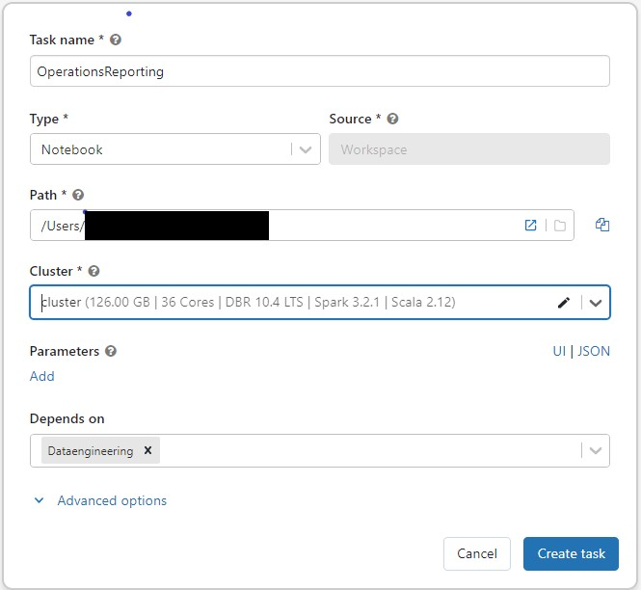
Job View

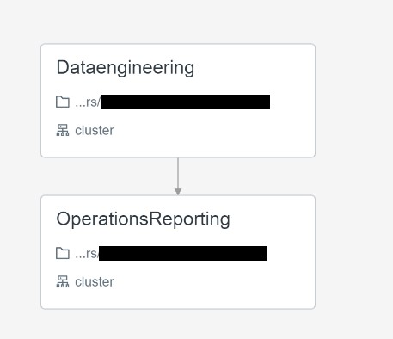

Domain - Building Production Pipelines
Question 18

The data engineering team noticed that one of the job normally finishes in 15 mins but gets stuck randomly when reading remote databases due to a network packet drop, which of the following steps can be used to improve the stability of the job?

- Use Databrick REST API to monitor long running jobs and issue a kill command
- Use Jobs runs, active runs UI section to monitor and kill long running job
- Modify the task, to include a timeout to kill the job if it runs more than 15 mins. (Correct answer)
- Use Spark job time out setting in the Spark UI
- Use Cluster timeout setting in the Job cluster UI

Overall explanation
https://docs.microsoft.com/en-us/azure/databricks/data-engineering/jobs/jobs#timeout

Domain
Building Production Pipelines

Question 19Correct

Which of the following programming languages can be used to build a Databricks SQL dashboard?

- Python
- Scala
- SQL (Correct answer)
- R
- All of the above

Domain- Building Production Pipelines

Question 20

The data analyst team had put together queries that identify items that are out of stock based on orders and replenishment but when they run all together for final output the team noticed it takes a really long time, you were asked to look at the reason why queries are running slow and identify steps to improve the performance and when you looked at it you noticed all the code queries are running sequentially and using a SQL endpoint cluster. Which of the following steps can be taken to resolve the issue?
Here is the example query
- --- Get order summary
- create or replace table orders_summary
- as
- select product_id, sum(order_count) order_count
- from
- (
- select product_id,order_count from orders_instore
- union all
- select product_id,order_count from orders_online
- )
- group by product_id
- -- get supply summary
- create or repalce tabe supply_summary
- as
- select product_id, sum(supply_count) supply_count
- from supply
- group by product_id

- -- get on hand based on orders summary and supply summary

- with stock_cte
- as (
- select nvl(s.product_id,o.product_id) as product_id,
- nvl(supply_count,0) - nvl(order_count,0) as on_hand
- from supply_summary s
- full outer join orders_summary o
- on s.product_id = o.product_id
- )
- select *
- from
- stock_cte
- where on_hand = 0
- Turn on the Serverless feature for the SQL endpoint.
- Increase the maximum bound of the SQL endpoint’s scaling range.
- Increase the cluster size of the SQL endpoint. (Correct answer)
- Turn on the Auto Stop feature for the SQL endpoint.
- Turn on the Serverless feature for the SQL endpoint and change the Spot Instance Policy to “Reliability Optimized.”

Overall explanation
Here queries are running sequentially and since the single query can not span more than one cluster adding more clusters won't improve the query but rather increasing the cluster size will improve performance so it can use additional compute in a warehouse.
In the exam please note that additional context will not be given instead you have to look for cue words or need to understand if the queries are running sequentially or concurrently. if the queries are running sequentially then scale up(more nodes) if the queries are running concurrently (more users) then scale out(more clusters).
Below is the snippet from Azure, as you can see by increasing the cluster size you are able to add more worker nodes.
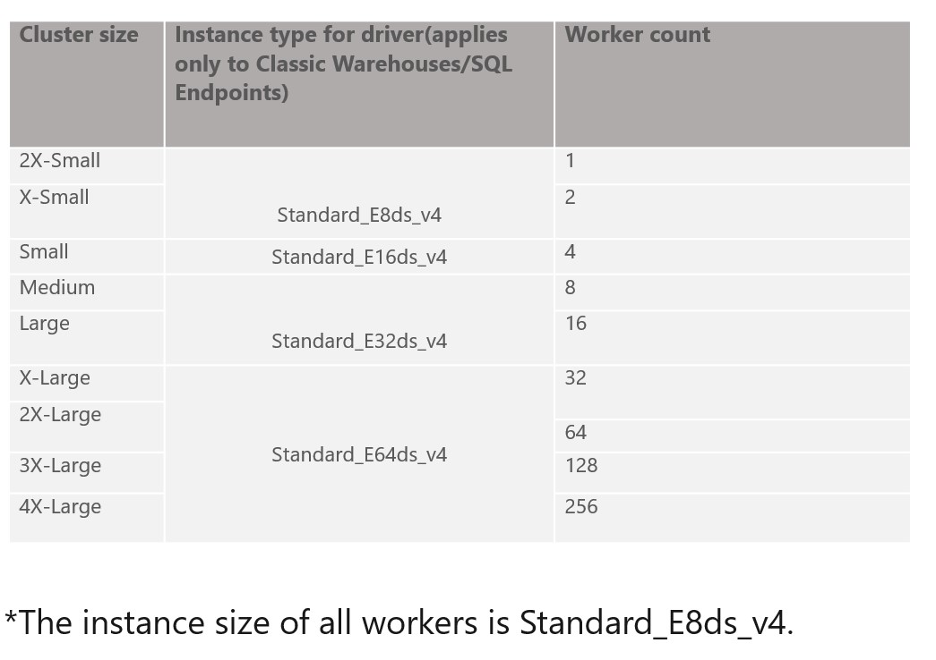
SQL endpoint scales horizontally(scale-out) and vertically (scale-up), you have to understand when to use what.
Scale-up-> Increase the size of the cluster from x-small to small, to medium, X Large....
If you are trying to improve the performance of a single query having additional memory, additional nodes and cpu in the cluster will improve the performance.
Scale-out -> Add more clusters, change max number of clusters
If you are trying to improve the throughput, being able to run as many queries as possible then having an additional cluster(s) will improve the performance.
SQL endpoint
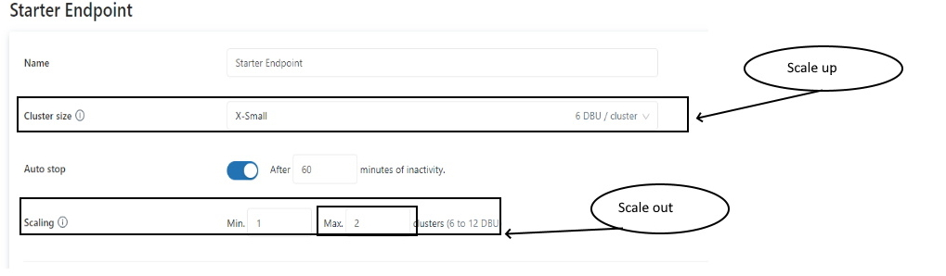

Domain - Building Production Pipelines

Question 21

The operations team is interested in monitoring the recently launched product, team wants to set up an email alert when the number of units sold increases by more than 10,000 units. They want to monitor this every 5 mins.
Fill in the below blanks to finish the steps we need to take
· Create ___ query that calculates total units sold
· Setup ____ with query on trigger condition Units Sold > 10,000
· Setup ____ to run every 5 mins
· Add destination ______

- Python, Job, SQL Cluster, email address
- SQL, Alert, Refresh, email address (Correct answer)
- SQL, Job, SQL Cluster, email address
- SQL, Job, Refresh, email address
- Python, Job, Refresh, email address

Overall explanation
The answer is SQL, Alert, Refresh, email address
Here the steps from Databricks documentation,
Create an alert
Follow these steps to create an alert on a single column of a query.
- Do one of the following:
  - Click
Create in the sidebar and select Alert.
  - Click
Alerts in the sidebar and click the + New Alert button.
- Search for a target query.
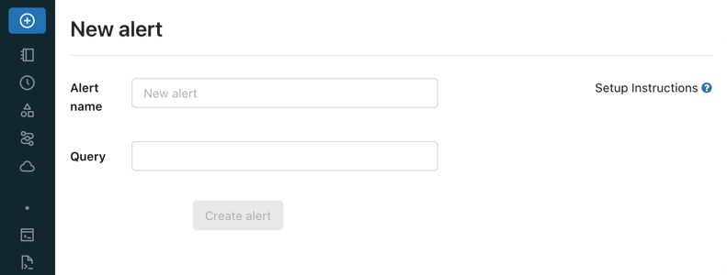
To alert on multiple columns, you need to modify your query. See Alert on multiple columns.
- In the Trigger when field, configure the alert.
  - The Value column drop-down controls which field of your query result is evaluated.
  - The Condition drop-down controls the logical operation to be applied.
  - The Threshold text input is compared against the Value column using the Condition you specify.
Note
If a target query returns multiple records, Databricks SQL alerts act on the first one. As you change the Value column setting, the current value of that field in the top row is shown beneath it.
- In the When triggered, send notification field, select how many notifications are sent when your alert is triggered:
  - Just once: Send a notification when the alert status changes from OK to TRIGGERED.
  - Each time alert is evaluated: Send a notification whenever the alert status is TRIGGERED regardless of its status at the previous evaluation.
  - At most every: Send a notification whenever the alert status is TRIGGERED at a specific interval. This choice lets you avoid notification spam for alerts that trigger often.
Regardless of which notification setting you choose, you receive a notification whenever the status goes from OK to TRIGGERED or from TRIGGERED to OK. The schedule settings affect how many notifications you will receive if the status remains TRIGGERED from one execution to the next. For details, see Notification frequency.
- In the Template drop-down, choose a template:
  - Use default template: Alert notification is a message with links to the Alert configuration screen and the Query screen.
  - Use custom template: Alert notification includes more specific information about the alert.
    - A box displays, consisting of input fields for subject and body. Any static content is valid, and you can incorporate built-in template variables:
      - ALERT_STATUS: The evaluated alert status (string).
      - ALERT_CONDITION: The alert condition operator (string).
      - ALERT_THRESHOLD: The alert threshold (string or number).
      - ALERT_NAME: The alert name (string).
      - ALERT_URL: The alert page URL (string).
      - QUERY_NAME: The associated query name (string).
      - QUERY_URL: The associated query page URL (string).
      - QUERY_RESULT_VALUE: The query result value (string or number).
      - QUERY_RESULT_ROWS: The query result rows (value array).
      - QUERY_RESULT_COLS: The query result columns (string array).
An example subject, for instance, could be: Alert "{{ALERT_NAME}}" changed status to {{ALERT_STATUS}}.
    - Click the Preview toggle button to preview the rendered result.
Important
The preview is useful for verifying that template variables are rendered correctly. It is not an accurate representation of the eventual notification content, as each alert destination can display notifications differently.
    - Click the Save Changes button.
- In Refresh, set a refresh schedule. An alert’s refresh schedule is independent of the query’s refresh schedule.
  - If the query is a Run as owner query, the query runs using the query owner’s credential on the alert’s refresh schedule.
  - If the query is a Run as viewer query, the query runs using the alert creator’s credential on the alert’s refresh schedule.
- Click Create Alert.
- Choose an alert destination.

Domain - Building Production Pipelines

Question 22

The marketing team is launching a new campaign to monitor the performance of the new campaign for the first two weeks, they would like to set up a dashboard with a refresh schedule to run every 5 minutes, which of the below steps can be taken to reduce of the cost of this refresh over time?

- Reduce the size of the SQL Cluster size
- Reduce the max size of auto scaling from 10 to 5
- Setup the dashboard refresh schedule to end in two weeks (Correct answer)
- Change the spot instance policy from reliability optimized to cost optimized
- Always use X-small cluster

Overall explanation
The answer is Setup the dashboard refresh schedule to end in two weeks

Domain
Building Production Pipelines

Question 23Correct

Which of the following tool provides Data Access control, Access Audit, Data Lineage, and Data discovery?

- DELTA LIVE Pipelines
- Unity Catalog (Correct answer)
- Data Governance
- DELTA lake
- Lakehouse

Domain
Data Governance

Question 24Correct
Data engineering team is required to share the data with Data science team and both the teams are using different workspaces in the same organizationwhich of the following techniques can be used to simplify sharing data across?
*Please note the question is asking how data is shared within an organization across multiple workspaces.
- Data Sharing
- Unity Catalog (Correct answer)
- DELTA lake
- Use a single storage location
- DELTA LIVE Pipelines

Overall explanation
The answer is the Unity catalog.
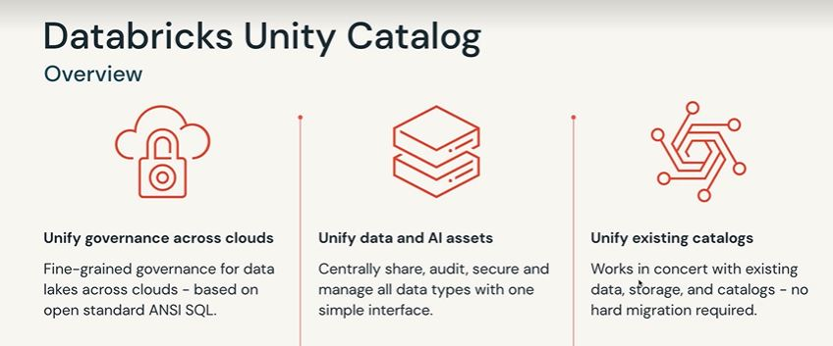
Unity Catalog works at the Account level, it has the ability to create a meta store and attach that meta store to many workspaces
see the below diagram to understand how Unity Catalog Works, as you can see a metastore can now be shared with both workspaces using Unity Catalog, prior to Unity Catalog the options was to use single cloud object storage manually mount in the second databricks workspace, and you can see here Unity Catalog really simplifies that.
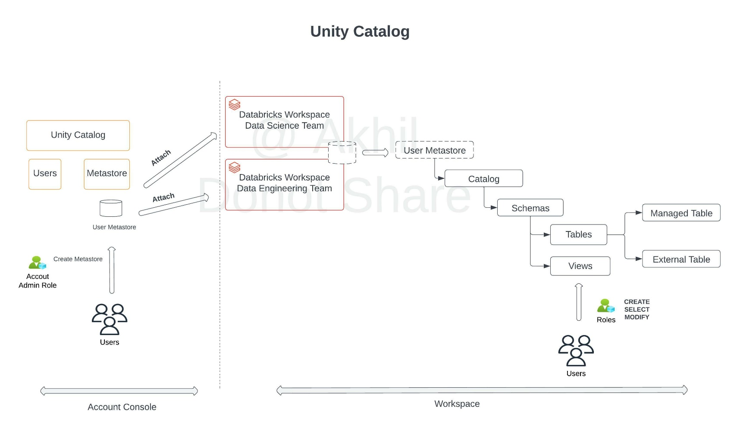

Review product features
https://databricks.com/product/unity-catalog
Question 25

A newly joined team member John Smith in the Marketing team who currently does not have any access to the data requires read access to customers table, which of the following statements can be used to grant access.

- GRANT SELECT, USAGE TO john.smith@marketing.com ON TABLE customers
- GRANT READ, USAGE TO john.smith@marketing.com ON TABLE customers
- GRANT SELECT, USAGE ON TABLE customers TO john.smith@marketing.com (Correct answer)
- GRANT READ, USAGE ON TABLE customers TO john.smith@marketing.com
- GRANT READ, USAGE ON customers TO john.smith@marketing.com

Overall explanation
The answer is GRANT SELECT, USAGE ON TABLE customers TO john.smith@marketing.com
Data object privileges - Azure Databricks | Microsoft Docs
Domain - Data Governance

Question 26

Grant full privileges to new marketing user Kevin Smith to table sales

- GRANT FULL PRIVILEGES TO kevin.smith@marketing.com ON TABLE sales
- GRANT ALL PRIVILEGES TO kevin.smith@marketing.com ON TABLE sales
- GRANT FULL PRIVILEGES ON TABLE sales TO kevin.smith@marketing.com
- GRANT ALL PRIVILEGES ON TABLE sales TO kevin.smith@marketing.com (Correct answer)
- GRANT ANY PRIVILEGE ON TABLE sales TO kevin.smith@marketing.com

Overall explanation
The answer is GRANT ALL PRIVILEGE ON TABLE sales TO kevin.smith@marketing.com
GRANT <privilege> ON <securable_type> <securable_name> TO <principal>
Here are the available privileges and ALL Privileges gives full access to an object.
Privileges
- SELECT: gives read access to an object.
- CREATE: gives ability to create an object (for example, a table in a schema).
- MODIFY: gives ability to add, delete, and modify data to or from an object.
- USAGE: does not give any abilities, but is an additional requirement to perform any action on a schema object.
- READ_METADATA: gives ability to view an object and its metadata.
- CREATE_NAMED_FUNCTION: gives ability to create a named UDF in an existing catalog or schema.
- MODIFY_CLASSPATH: gives ability to add files to the Spark class path.
- ALL PRIVILEGES: gives all privileges (is translated into all the above privileges).

Question 27

Which of the following locations in the Databricks product architecture hosts the notebooks and jobs?

- Data plane
- Control plane (Correct answer)
- Databricks Filesystem
- JDBC data source
- Databricks web application

Overall explanation
Databricks operates most of its services out of a control plane and a data plane, please note serverless features like SQL Endpoint and DLT compute use shared compute in Control pane.
Control Plane: Stored in Databricks Cloud Account
- The control plane includes the backend services that Databricks manages in its own Azure account. Notebook commands and many other workspace configurations are stored in the control plane and encrypted at rest.
Data Plane: Stored in Customer Cloud Account
- The data plane is managed by your Azure account and is where your data resides. This is also where data is processed. You can use Azure Databricks connectors so that your clusters can connect to external data sources outside of your Azure account to ingest data or for storage.

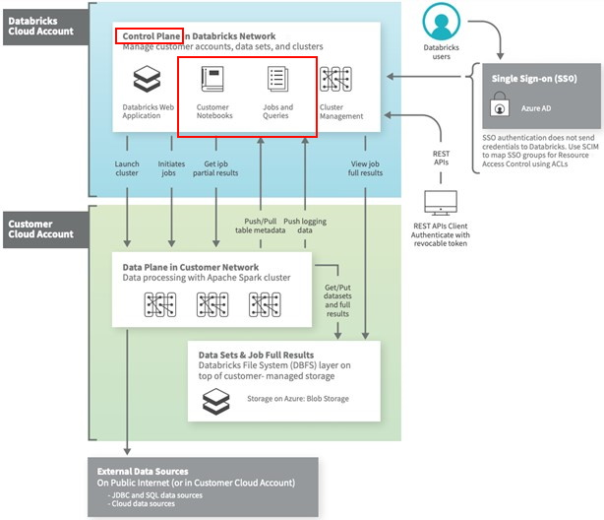

Domain - Databricks Lakehouse Platform

Question 28

What could be the expected output of query SELECT COUNT (DISTINCT *) FROM user on this table

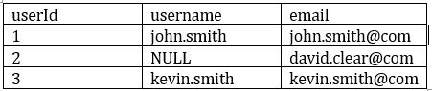

- 3
- 2 (Correct answer)
- 1
- 0
- NULL

Overall explanation
The answer is 2,
Count(DISTINCT *) removes rows with any column with a NULL value
Domain - ELT with Spark SQL and Python

Question 29

You are still noticing slowness in query after performing optimize which helped you to resolve the small files problem, the column(transactionId) you are using to filter the data has high cardinality and auto incrementing number. Which delta optimization can you enable to filter data effectively based on this column?

- Create BLOOM FLTER index on the transactionId
- Perform Optimize with Zorder on transactionId (Correct answer)
- transactionId has high cardinality, you cannot enable any optimization.
- Increase the cluster size and enable delta optimization
- Increase the driver size and enable delta optimization

Overall explanation
Here is a simple explanation of how Z-order works, once the data is naturally ordered, when a flle is scanned it only brings the data it needs into spark's memory
Based on the column min and max it knows which data files needs to be scanned.
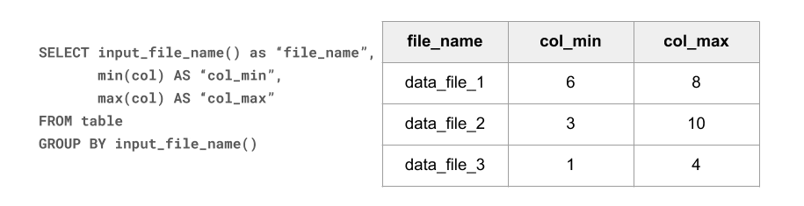

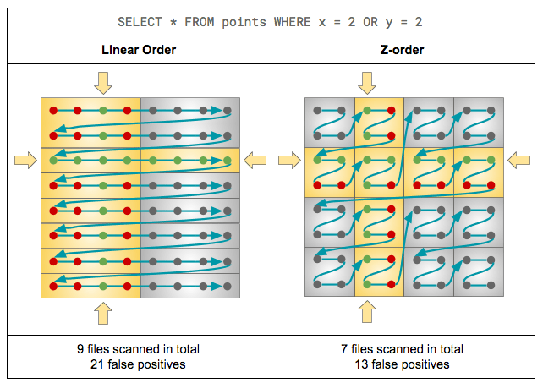
Domain - Databricks Lakehouse Platform

Question 30

If you create a database sample_db with the statement CREATE DATABASE sample_db what will be the default location of the database in DBFS?

- Default location, DBFS:/user/
- Default location, /user/db/
- Default Storage account
- Statement fails “Unable to create database without location”
- Default Location, dbfs:/user/hive/warehouse (Correct answer)

Overall explanation
The Answer is dbfs:/user/hive/warehouse this is the default location where spark stores user databases, the default can be changed using spark.sql.warehouse.dir a parameter. You can also provide a custom location using the LOCATION keyword.
Here is how this works,
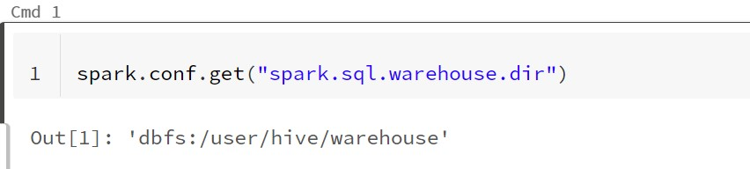
Default location

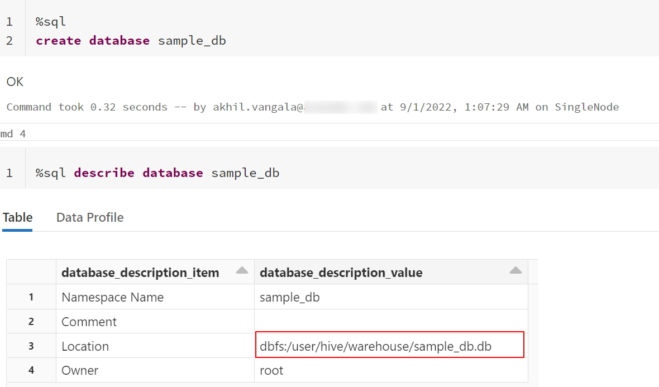
FYI, This can be changed used using cluster spark config or session config.
Modify spark.sql.warehouse.dir location to change the default location
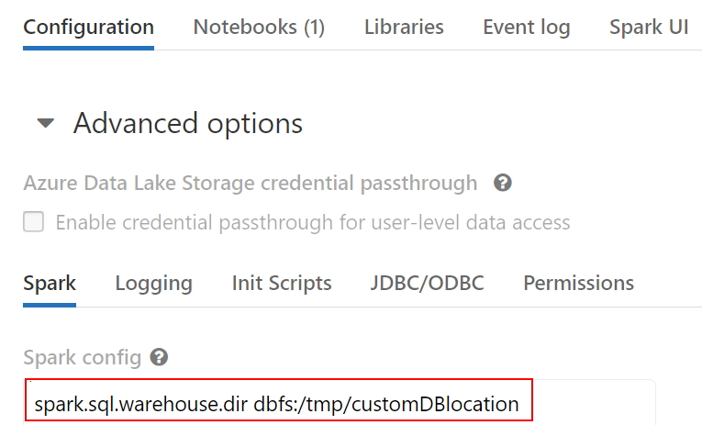

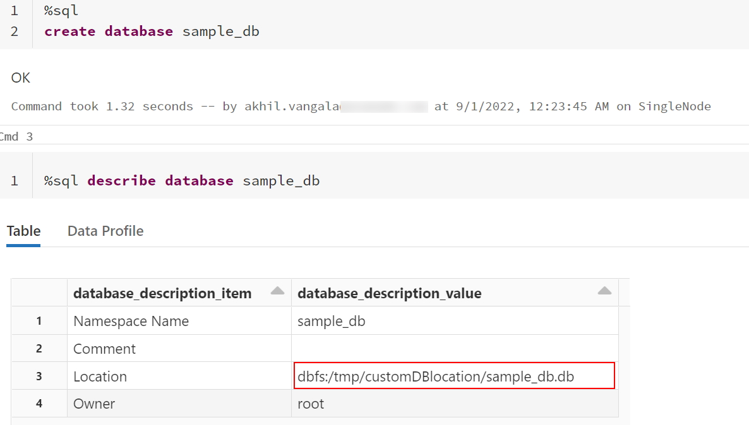

Domain - ELT with Spark SQL and Python

Question 31

Which of the following results in the creation of an external table?
- CREATE TABLE transactions (id int, desc string) USING DELTA LOCATION EXTERNAL
- CREATE TABLE transactions (id int, desc string)
- CREATE EXTERNAL TABLE transactions (id int, desc string)
- CREATE TABLE transactions (id int, desc string) TYPE EXTERNAL
- CREATE TABLE transactions (id int, desc string) LOCATION '/mnt/delta/transactions' (Correct answer)

Overall explanation
Answer is CREATE TABLE transactions (id int, desc string) USING DELTA LOCATION ‘/mnt/delta/transactions’
Anytime a table is created using Location it is considered an external table, below is the current syntax.
Syntax
CREATE TABLE table_name ( column column_data_type…) USING format LOCATION “dbfs:/”

Domain - ELT with Spark SQL and Python

Question 32

When you drop an external DELTA table using the SQL Command DROP TABLE table_name, how does it impact metadata(delta log, history), and data stored in the storage?

- Drops table from metastore, metadata(delta log, history)and data in storage
- Drops table from metastore, data but keeps metadata(delta log, history) in storage
- Drops table from metastore, metadata(delta log, history)but keeps the data in storage
- Drops table from metastore, but keeps metadata(delta log, history)and data in storage (Correct answer)
- Drops table from metastore and data in storage but keeps metadata(delta log, history)

Overall explanation
The answer is Drops table from metastore, but keeps metadata and data in storage.
When an external table is dropped, only the table definition is dropped from metastore everything including data and metadata(Delta transaction log, time travel history) remains in the storage. Delta log is considered as part of metadata because if you drop a column in a delta table(managed or external) the column is not physically removed from the parquet files rather it is recorded in the delta log. The delta log becomes a key metadata layer for a Delta table to work.
Domain - ELT with Spark SQL and Python

Question 33

Which of the following is a true statement about the global temporary view?

- A global temporary view is available only on the cluster it was created, when the cluster restarts global temporary view is automatically dropped. (Correct answer)
- A global temporary view is available on all clusters for a given workspace
- A global temporary view persists even if the cluster is restarted
- A global temporary view is stored in a user database
- A global temporary view is automatically dropped after 7 days

Overall explanation
The answer is, A global temporary view is available only on the cluster it was created.
Two types of temporary views can be created Session scoped and Global
- A session scoped temporary view is only available with a spark session, so another notebook in the same cluster can not access it. if a notebook is detached and re attached the temporary view is lost.
- A global temporary view is available to all the notebooks in the cluster, if a cluster restarts global temporary view is lost.

Domain - ELT with Spark SQL and Python

Question 34

You are trying to create an object by joining two tables that and it is accessible to data scientist’s team, so it does not get dropped if the cluster restarts or if the notebook is detached. What type of object are you trying to create?

- Temporary view
- Global Temporary view
- Global Temporary view with cache option
- External view
- View (Correct answer)

Overall explanation
Answer is View, A view can be used to join multiple tables but also persist into meta stores so others can accesses it

Domain - ELT with Spark SQL and Python

Question 35

What is the best way to query external csv files located on DBFS Storage to inspect the data using SQL?

- SELECT * FROM 'dbfs:/location/csv_files/' FORMAT = 'CSV'
- SELECT CSV. * from 'dbfs:/location/csv_files/'
- SELECT * FROM CSV. 'dbfs:/location/csv_files/' (Correct answer)
- You can not query external files directly, us COPY INTO to load the data into a table first
- SELECT * FROM 'dbfs:/location/csv_files/' USING CSV

Overall explanation
you can query external files stored on the storage using below syntax
SELECT * FROM format.`/Location`
format - CSV, JSON, PARQUET, TEXT

Domain - ELT with Spark SQL and Python

Question 36

Direct query on external files limited options, create external tables for CSV files with header and pipe delimited CSV files, fill in the blanks to complete the create table statement

CREATE TABLE sales (id int, unitsSold int, price FLOAT, items STRING)
________
________

LOCATION “dbfs:/mnt/sales/*.csv”

FORMAT CSV
OPTIONS ( “true”,”|”)

USING CSV
TYPE ( “true”,”|”)

(Correct answer)
USING CSV
OPTIONS ( header =“true”, delimiter = ”|”)

FORMAT CSV
FORMAT TYPE ( header =“true”, delimiter = ”|”)

FORMAT CSV
TYPE ( header =“true”, delimiter = ”|”)

Overall explanation
Here is the syntax to create an external table with additional options
CREATE TABLE table_name (col_name1 col_typ1,..)
USING data_source
OPTIONS (key=’value’, key2=vla2)
LOCATION = “/location“

Domain - ELT with Spark SQL and Python

Question 37

At the end of the inventory process, a file gets uploaded to the cloud object storage, you are asked to build a process to ingest data which of the following method can be used to ingest the data incrementally, schema of the file is expected to change overtime ingestion process should be able to handle these changes automatically. Below is the auto loader to command to load the data, fill in the blanks for successful execution of below code.

- spark.readStream
- .format("cloudfiles")
- .option("_______",”csv)
- .option("_______", ‘dbfs:/location/checkpoint/’)
- .load(data_source)
- .writeStream
- .option("_______",’ dbfs:/location/checkpoint/’)
- .option("_______", "true")
- .table(table_name))
- format, checkpointlocation, schemalocation, overwrite
- cloudfiles.format, checkpointlocation, cloudfiles.schemalocation, overwrite
- cloudfiles.format, cloudfiles.schemalocation, checkpointlocation, mergeSchema (Correct answer)
- cloudfiles.format, cloudfiles.schemalocation, checkpointlocation, overwrite
- cloudfiles.format, cloudfiles.schemalocation, checkpointlocation, append

Overall explanation
Here is the end to end syntax of streaming ELT, below link contains complete options Auto Loader options | Databricks on AWS
- spark.readStream
- .format("cloudfiles") # Returns a stream data source, reads data as it arrives based on the trigger.
- .option("cloudfiles.format","csv") # Format of the incoming files
- .option("cloudfiles.schemalocation", "dbfs:/location/checkpoint/") The location to store the inferred schema and subsequent changes
- .load(data_source)
- .writeStream
- .option("checkpointlocation","dbfs:/location/checkpoint/") # The location of the stream’s checkpoint
- .option("mergeSchema", "true") # Infer the schema across multiple files and to merge the schema of each file. Enabled by default for Auto Loader when inferring the schema.
- .table(table_name)) # target table

Domain - Incremental Data Processing

Question 38

You are working on a table called orders which contains data for 2021 and you have the second table called orders_archive which contains data for 2020, you need to combine the data from two tables and there could be a possibility of the same rows between both the tables, you are looking to combine the results from both the tables and eliminate the duplicate rows, which of the following SQL statements helps you accomplish this?

- SELECT * FROM orders UNION SELECT * FROM orders_archive (Correct answer)
- SELECT * FROM orders INTERSECT SELECT * FROM orders_archive
- SELECT * FROM orders UNION ALL SELECT * FROM orders_archive
- SELECT * FROM orders_archive MINUS SELECT * FROM orders
- SELECT distinct * FROM orders JOIN orders_archive on order.id = orders_archive.id

Overall explanation
Answer is SELECT * FROM orders UNION SELECT * FROM orders_archive
UNION and UNION ALL are set operators,
UNION combines the output from both queries but also eliminates the duplicates.
UNION ALL combines the output from both queries.

Domain - ELT with Spark SQL and Python

Question 39

Which of the following python statement can be used to replace the schema name and table name in the query statement?

- table_name = "sales"
- schema_name = "bronze"
- query = f”select * from schema_name.table_name”
- table_name = "sales"
- schema_name = "bronze"
- query = "select * from {schema_name}.{table_name}"
(Correct answer)
- table_name = "sales"
- schema_name = "bronze"
- query = f"select * from { schema_name}.{table_name}"
- table_name = "sales"
- schema_name = "bronze"
- query = f"select * from + schema_name +"."+table_name"

Domain - ELT with Spark SQL and Python

Question 40

Which of the following SQL statements can replace python variables in Databricks SQL code, when the notebook is set in SQL mode?

- %python
- table_name = "sales"
- schema_name = "bronze"

- %sql
- SELECT * FROM ____________________
- SELECT * FROM f{schema_name.table_name}
- SELECT * FROM {schem_name.table_name}
- SELECT * FROM ${schema_name}.${table_name} (Correct answer)
- SELECT * FROM schema_name.table_name

Domain - ELT with Spark SQL and Python

Question 41

A notebook accepts an input parameter that is assigned to a python variable called department and this is an optional parameter to the notebook, you are looking to control the flow of the code using this parameter. you have to check department variable is present then execute the code and if no department value is passed then skip the code execution. How do you achieve this using python?

(Correct answer)
- if department is not None:
- #Execute code
- else:
- pass
- if (department is not None)
- #Execute code
- else
- pass
- if department is not None:
- #Execute code
- end:
- pass
- if department is not None:
- #Execute code
- then:
- pass
- if department is None:
- #Execute code
- else:
- pass
Domain - ELT with Spark SQL and Python

Question 42
Which of the following operations are not supported on a streaming dataset view?
spark.readStream.format("delta").table("sales").createOrReplaceTempView("streaming_view")
- SELECT sum(unitssold) FROM streaming_view
- SELECT max(unitssold) FROM streaming_view
- SELECT id, sum(unitssold) FROM streaming_view GROUP BY id ORDER BY id
- SELECT id, count(*) FROM streaming_view GROUP BY id
- SELECT * FROM streadming_view ORDER BY id (Correct answer)

Please Note: Sorting without aggregation function is not supported but Sorting with Group by will work without any issues

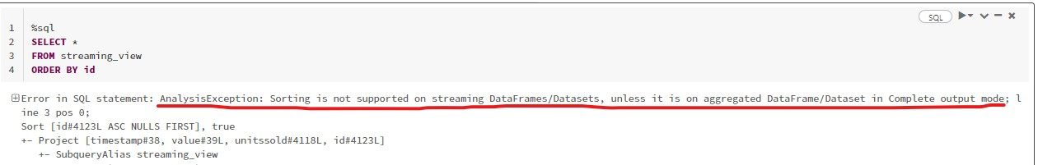
Certain operations are not allowed on streaming data, please see highlighted in bold.
https://spark.apache.org/docs/latest/structured-streaming-programming-guide.html#unsupported-operations
- Multiple streaming aggregations (i.e. a chain of aggregations on a streaming DF) are not yet supported on streaming Datasets.
- Limit and take the first N rows are not supported on streaming Datasets.
- Distinct operations on streaming Datasets are not supported.
- Deduplication operation is not supported after aggregation on a streaming Datasets.
- Sorting operations are supported on streaming Datasets only after an aggregation and in Complete Output Mode.
Note: Sorting without aggregation function is not supported.
Here is the sample code to prove this, Setup test stream
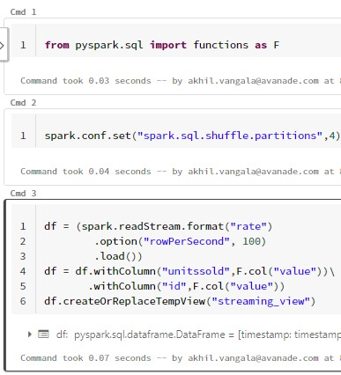

Sum aggregation function has no issues on stream
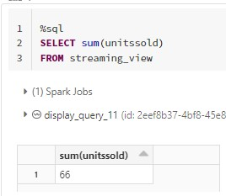

Max aggregation function has no issues on stream
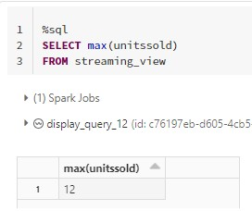
Group by with Order by has no issues on stream
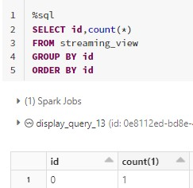
Group by has no issues on stream
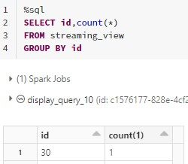

Order by without group by fails.

Domain - Incremental Data Processing

Question 43

Which of the following techniques structured streaming uses to ensure recovery of failures during stream processing?

- Checkpointing and Watermarking
- Write ahead logging and watermarking
- Checkpointing and write-ahead logging (Correct answer)
- Delta time travel
- The stream will failover to available nodes in the cluster
- Checkpointing and Idempotent sinks

Overall explanation
Structured Streaming uses checkpointing and write-ahead logs to record the offset range of data being processed during each trigger interval.

Domain - Incremental Data Processing

Question 44

What is the underlying technology that makes the Auto Loader work?

- Loader
- Delta Live Tables
- Structured Streaming (Correct answer)
- DataFrames
- Live DataFames

Overall explanation
Auto Loader is built on top of Structured Streaming, Auto Loader provides a Structured Streaming source called cloudFiles. Given an input directory path on the cloud file storage, the cloudFiles source automatically processes new files as they arrive, with the option of also processing existing files in that directory

Domain - Incremental Data Processing

Question 45

You are currently working to ingest millions of files that get uploaded to the cloud object storage for consumption, and you are asked to build a process to ingest this data, the schema of the file is expected to change over time, and the ingestion process should be able to handle these changes automatically. Which of the following method can be used to ingest the data incrementally?

- AUTO APPEND
- AUTO LOADER (Correct answer)
- COPY INTO
- Structured Streaming
- Checkpoint

Overall explanation
Use Auto Loader instead of the COPY INTO SQL command when:
- You want to load data from a file location that contains files in the order of millions or higher. Auto Loader can discover files more efficiently than the COPY INTO SQL command and can split file processing into multiple batches.
- COPY INTO only directory listing but AUTO LOADER supports File notification method where the Auto Loader continues to ingest files as they arrive in cloud object storage leveraging cloud provider(Queues and triggers) and Spark's structured streaming.
- Your data schema evolves frequently. Auto Loader provides better support for schema inference and evolution. See Configuring schema inference and evolution in Auto Loader.

Domain - Incremental Data Processing

